**Literature review**

A mobile web app is a mobile application that combines the versatility of the web with the functionality of touch-enabled devices because mobile web apps are web-based; they are compatible with both iPhone and Android smartphones making it easy to deliver the content to a large mobile audience.The advancement of mobile technology has enabled the development of a wide range of application used by many people on the move. Over the year’s mobile technology have become more embedded and universal with enhanced capabilities for interaction and internet connectivity.

In recent articles published in Trinidad and Tobago Guardian and Express newspapers the Minister of Health noted that in most public hospitals in Trinidad there is an overcrowding issue. There are more patients than the number of beds and this is due because of the lack of proper track record keeping of each patient. Patients get discharged and they remain in the wards, because of the lack of record keeping, both administrative and medical staff is unaware which patient have been discharged and which beds are available. Most hospitals in the Caribbean use manual record keeping. The WCA Hospital in the United States of America uses electronic means for storing patient’s information.

Medical Management Admittance Application is an application that will be used by the nurses in the Triage and the Bed Bureau staff in an attempt to eliminate the overcrowding of public hospital in Trinidad and Tobago. It allows for both entering and retrieving of beds and ward information such as which beds are occupied or vacant and the wards such beds exits. Only when a person is admitted to the ward/hospital their records are entered into the system. Each ward has a limited amount of space/beds which allows staff to keep track of how many patients can actually be admitted and the total number of patients currently in the system.

Eric Williams Medical Sciences Complex (EWMSC) is one of the leading public health facilities in Trinidad originally opened in 1990; started the hospital with out-patient clinics. They moved the Paediatric clinic completely to the Mt Hope hospital. The reason for this was that Mt Hope was supposed to be the premiere Paediatric Hospital of Trinidad and Tobago. There was a Paediatric Clinic but no in service beds, a Paediatric Surgery Clinic but no surgery. The University Staff ran the Paediatric Hospital at that time. Professor Pitt-Miller who was no longer the Head of Anaesthetics at Port of Spain Hospital but was still the academic head at UWI; was asked by the Head of Paediatrics at Mt Hope if she could service patients one day a week at the Paediatric Hospital in order to start surgery. Surgery started with out-patient problems like hernias. Trevor Romano at that time was the Chief Executive Officer (CEO) of the Eric Williams Medical Authority who ran the EWMSC. Mt Hope at that time was semi-private so patrons had to pay for service. The management at that time always wondered whether they were doing the right thing having patients pay for medical attention. The original design for this hospital was that it was supposed to be the teaching hospital for the Medical School. The design of the hospital was in tune with that model; this plan however was never followed. The Mt Hope Women's Hospital as well as the St Joseph Health Centre (as a primary health centre and family medicine centre) was part of the original proposal for the Facility.  They were supposed to be part of the teaching for medical students. In essence everything needed to teach the students would be here. 2005.

Based on interview conducted at the Eric Williams Medical Sciences Complex it indicated that public hospitals in Trinidad have been experiencing overcrowding of beds. Increasingly public hospitals in have more patients that need beds than there are beds to accommodate them. Overflow patients are kept on care stretchers in the Emergency Department and are kept as “corridor” patients. The purpose of the project is to develop an application that will track the number of beds and the ward number to which these beds are available. The use of mobile applications for patient’s admittance could improve the well-being of people in Trinidad.

Modular overview of Cellma

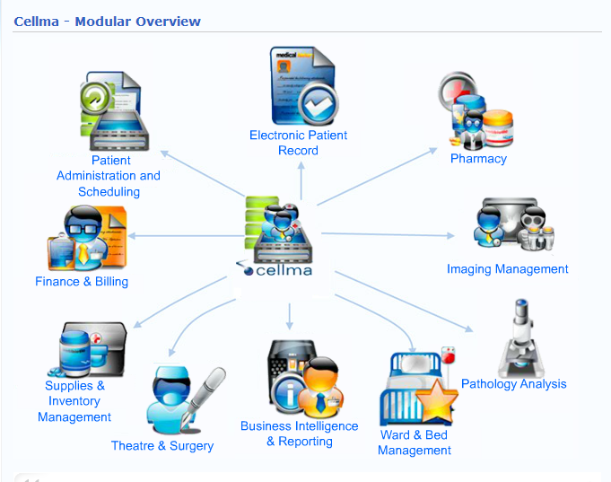The Eric Williams Medical Services Complex, one of the leading health institutions in the Caribbean have recently deployed Cellma, RioMed’s flagship software is a health information system designed for healthcare professionals by healthcare professionals (As of February 26, 2014, RioMed). It is used to improve the efficiency and productivity on a daily basis by eliminating the use of paper during registration of potential patients.

Based on interview with staff member the admittance process begins with patient’s information being entered into Cellma. After doctors and nurses have examined and conducted basic tests, nurses in the Triage determine whether patients need to be admitted. The allocation of beds in the hospital is done by the bed bureau, whose responsibility is to go to each ward in the hospital at regular intervals taking note of the beds that are free. The bed bureau then returns with a list of available beds and ward numbers, that the nurses in the Triage, nurses uses this list to allocate patients to available beds.

Agile approaches to software development consider design and implementation to be the central activities in the software process. They incorporate other activities, such as requirements elicitation and testing, into design and implementation. By contrast, a plan-driven approach to software engineering identifies separate stages in the software process with outputs associated with each stage (Sommerville, 62). Scrum an agile approach allows teams to work together to develop a product. Product development, using such method occurs in small pieces, with pieces building upon previously built pieces. Building products one piece at a time encourages creativity and enables teams to respond to feedback and changes as compared to the waterfall model, success is defined by achieving the planned scope.

There are many methods and frameworks that could be used in order to complete this web application. The PHP framework we chose is “Codeigniter” and the front-end framework chosen is “Bootstrap”. Codeigniter was chosen as oppose to other frameworks such as “Zend” or “CakePHP” for a few reasons. Firstly, Codeigniter has one of the most clear and thorough documentations of all the PHP frameworks. Also, it has one of the smallest framework footprints for a fully baked PHP framework. Bootstrap is used because it is very intuitive and easy-to-use. There is extensive documentation about the features and other add-ons such as jQuery are easily incorporated with the framework.